Nicotine Replacement Therapy Products are Available For Sale At This Business

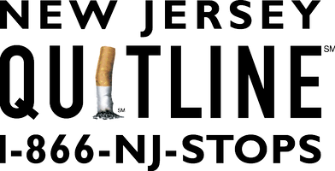
www.njquitline.org

